Chapter 1 DNA and genetics
extra worksheet 3: Mutations
As DNA is copied, mistakes can occur causing changes in the order of the bases along the DNA strand. This type of change is called a mutation. Some mutations happen naturally. Some mutations are the result of damage caused by chemicals, radiation or other factors. Factors that may cause mutations are known as mutagens. Mutations can result in the disease known as cancer, which is uncontrolled cell growth.
The effect of mutagens has been known for a very long time. Over 2500 years ago, long before chromosomes or DNA were discovered, the Greek philosopher Hippocrates identified tumours (cancerous growths) in patients. He described these as ‘cancer’ because the tumour shape resembled a crab, and the Greek words for crab were carcinos and karkinoma.
Ultraviolet (UV) light from the Sun is a natural mutagen, as are some viruses. Tobacco smoke contains mutagens. Mutagens are also found in some food and drink.

Point mutations
Mutagens affect DNA in different ways. Some mutagens change a single base in the DNA code. These are point mutations. A point mutation is shown in Figure 1. Changing only one base for another sometimes has little effect on the functioning of the gene.
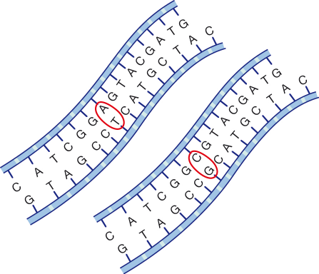

Figure 1
Example of a point mutation.

Frameshift mutations
Other mutagens delete or insert bases into the DNA molecule, causing a change in the sequence of bases that follow. These are major changes to the DNA and are known as frameshift mutations. A frameshift mutation is shown in Figure 2.
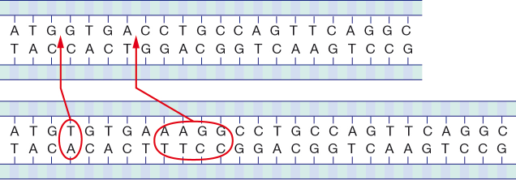
Figure 2
Example of a frameshift mutation.

Mutations and DNA repair
Infrequent (irregular) small doses of mutagens have little effect. Many potential mutations will be naturally repaired by your cells before the mutation can cause permanent damage. Proteins within the cell nucleus ‘cut out’ damaged sections of DNA and fill the gap with the correct sequence of bases.
But when mutations occur faster than they can be repaired, some areas of damage can go uncorrected. The genetic information can be permanently mutated and may cause disease. Permanent mutations can occur if you are exposed to a large amount of mutagen, or if small exposures are continued over a long period of time. For example, nicotine in cigarette smoke can block the process of repairing damaged DNA in lung cells. The result of long-term cigarette smoking is lung damage and potentially lung cancer, which can be fatal.

Mutated cells
Normal cells respond to changes in their environment in particular ways. Cells with mutated DNA do not behave normally. Mutations can occur in ordinary cells of the body (somatic cells) but they can also occur in the cells that produce gametes (germline cells), such as in the ovary and testes.
Mutations in somatic cells can damage the cells and change the functioning of organs; for example, mutated bone marrow cells can stop the bone marrow from functioning properly. Somatic mutations do not affect any offspring.
However, if a mutated egg or sperm produces an embryo, the germline mutations are passed on to the offspring. The mutation will be found in every cell of the new individual, including any gametes they produce. Germline mutations are passed from generation to generation.

Questions
1 Compare:
a a mutation and a mutagen

b a point mutation and a frameshift mutation

c a somatic mutation and a germline mutation.

2 Propose how mutations can occur without a mutagen being present.

3 Explain why it is impossible to avoid mutagens.

4 a Describe what normally happens in the body when a mutation occurs.

b Explain what is different when a person is exposed to high levels of a mutagen.

5 Explain why mutagens that affect the ovaries or testes are of more concern than other types of mutagens.

6 When genetic information is ‘read’ from DNA, each group of three bases is like a ‘word’; the more words that are changed, the more significant the mutation. Changing one word in the middle of a piece of DNA is a point mutation. Changing many words is a frameshift mutation.
a Classify the mutations in the table below as point mutation or frameshift mutations.
 | Original DNA code | Mutated DNA code | Mutation type
1 | AAT CGC GAT GGC TTA CCG | AAT CGC CAT GGC TTA CCG
2 | TTC CGA GGT CAG GAT CCA | TTC GCG AGG TCA GGA TCC
3 | AGG CAC GTT GCA AAT CGG | AGG CAC GTT GCA AAA CGG
4 | GGC CTA TGT GAA CCA GGT | GGC CTA TGA GAA CCA GGT
5 | GGC GGT TTA TGC CGA GCT | GGC GGT TTA ATG CCG AGC
6 | GCG ATC GGG ATA TCC ATA | GGG ATC GGG ATA TCC ATA

b Demonstrate the point where the mutation occurred by drawing a circle around it in the mutated code.
c Identify the parts of the DNA that have been changed by underlining them in the mutated code.

